
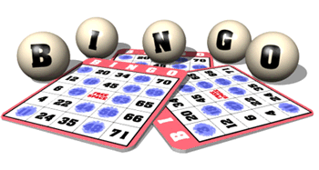

1st Cranwell (RAF) Brownies

Fundraising Prize Bingo

10 Games – 50p per book
Flyer – 15p per book

Friday 12th October 2012 - Cranwell Village Hall

Doors open 7pm

Eyes down 7.30pm

Children Welcome

